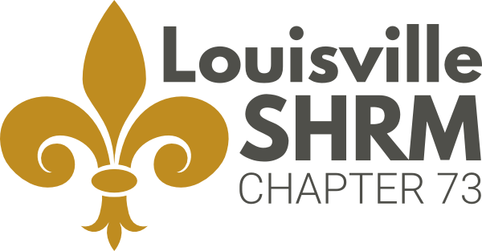
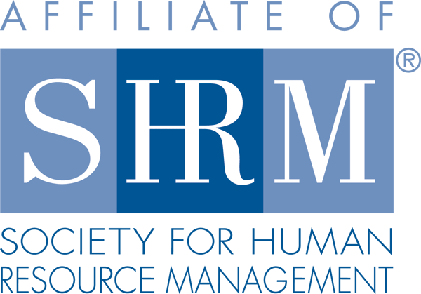

Louisville Society for Human Resource Management Receives Prestigious SHRM Award
for Advancing the HR Profession

LOUISVILLE, KY, May 21, 2018 — The Society for Human Resource Management (SHRM) recently awarded Louisville Society for Human Resource Management (LSHRM) its prestigious EXCEL Platinum Award for the chapter’s accomplishments in 2017.

The award aligns individual chapters’ activities with SHRM’s aspirations for the HR profession. The award recognizes accomplishments and strategic activities and initiatives that enhance the human resource profession.

“SHRM exists because of our great chapters and state councils like LSHRM which work tirelessly to help advance the important mission of the HR profession through initiatives that support our future, build inclusive organizations and focus on workplace readiness,” said Johnny C. Taylor, Jr., SHRM-SCP, president and chief executive officer of SHRM. “Recognizing you as a recipient of this prestigious award is just one way to show that SHRM supports you and that we are by your side step by step as we move Together Forward.”

The EXCEL Award can be earned at four levels: bronze, silver, gold and platinum. Each level has a prescribed set of requirements and accomplishments that must be met. LSHRM will receive recognition in SHRM publications and at conferences, a logo to display on its website, and information to share with its members about the significance of this award.

Under the outstanding leadership of 2017 President, Laura DeFazio, LSHRM served as a partner with employers and the community. The team worked to enhance awareness around the value of internship programs as a strategic talent pipeline resource, assisted over 200 job seekers with professional development training, and leveraged a partnership with Junior Achievement Kentuckiana to provide proactive workforce development education to young people.

For more information about LSHRM, visit www.lshrm.org.
Media: For more information, contact Patricia Williams of LSHRM at (502)650-1047 or pwilliams@lshrm.org.

About the Louisville Society for Human Resource Management
LSHRM is committed to excellence in the practice of human resource management and is Kentucky's largest professional human resources organization with nearly 600 members. LSHRM leads the effort to address Greater Louisville’s most pressing workforce challenges. LSHRM is committed to serving the community by providing bold and innovative workforce solutions.

About the Society for Human Resource Management

The Society for Human Resource Management (SHRM) is the world’s largest HR professional society, representing 285,000 members in more than 165 countries. For nearly seven decades, the Society has been the leading provider of resources serving the needs of HR professionals and advancing the practice of human resource management. SHRM has more than 575 affiliated chapters within the United States and subsidiary offices in China, India and United Arab Emirates. Visit us at shrm.org and follow us on Twitter and Instagram @SHRMPress.

